The University of Oklahoma

“Where Cyber Excellence Meets Sooner Spirit”

CyberSooners

Abel Macedo, Nicole Harrison, Braum Russell, Nathaniel Pumphrey, Mason Matray

MIS 4363 - Network Design

Dr. Patricia Angle

April 29, 2024

# **Executive Summary**

The goal of this project is to design a suitable and effective network for the Western Trucking main headquarters. The CyberSooners team analyzed the company’s network needs and crafted a logical design to fit them. Next, our team prepared a physical design plan based on the necessary hardware requirements determined from the previous phase. Lastly, our team performed a cost assessment in which we identified the specific pieces of hardware most appropriate and cost effective for the Western Trucking network design.

In analyzing Western Trucking’s network needs, we identified several departments likely to experience high network traffic. These departments include Security, Data Processing, Information Services, and Dispatch. As we split the building into Local Area Networks (LANs), we designated the LANs that would serve these departments as “High Traffic” and tinted with a red overlay, while LANs that would only service the remaining departments were classified as “Typical Traffic” and tinted with a green overlay. While creating a logical network design, we also indicated where the campus and building backbones would exist, denoted by a purple overlay. We also specified the location of networking closets with a yellow overlay, one in each building.

After establishing the network's logical design, CyberSooners developed a physical design, pinpointing where various hardware items would fit into the network. The two buildings will be connected by a high-speed router in each building’s network closet using a fiber connection, creating Western Trucking’s campus backbone. Switches that provide wired connectivity for access points and individual users within each room are connected via patch cables to the main router in each network closet. CyberSooners recommends four, twisted-pair, wired connections per room to ensure efficient and effective connections between hardware. Further, we designed an access point diagram based on a 2.4GHz frequency to create proper wireless connectivity within each building, while avoiding channel overlap and ensuring complete network coverage.

Based on the recommended specifications for Western Trucking’s network design, the CyberSooners have estimated a total equipment cost of about $25,079.76. Within this estimate is the necessary physical hardware and wire drops for ensuring proper connectivity. The CyberSooners have also included a “Good-to-Have” column in the cost assessment to provide a more effective option for the network design. These options greatly increase the total cost to roughly $57,825.76. Between the two options for each required piece of hardware, either offers growth flexibility and fully meets Western Trucking’s network needs.

**Contents**

**Executive Summary** **2**

**Get to Know the Team: (CyberSooners) 4**

**Project Description 5**

**Needs Analysis 6**

**Logical Network Design 8**

**Physical Network Design 9**

**Physical Network Design - Access Point Diagram** **10**

**Cost Assessment 11**

**Appendix 13**

**Team Contract 13**

**Device Specifications 14**

# **Get to Know the Team: (CyberSooners)**

Our team name, CyberSooners, was created to show our team’s focus on technology and innovation, mirroring the pioneer spirit of the original Sooners and the University of Oklahoma.

|  |  |  |  |  |  |
| --- | --- | --- | --- | --- | --- |
| Photo | Name | Major | Grade | Internship Experience | Background |
|  | Mason Matray | MIS & MIT | Junior | Incoming AI development intern and ranch hand. | I am from Blanchard, OK, with aspiring goals in data science. |
|  | Nicole Harrison | MIS, MIT, & Accounting | Junior | Scrum Master at Paycom and incoming IS intern at Valero. | I am from Overland Park, KS, and have served as a consultant for several nonprofit organizations. |
|  | Braum Russell | MIS & MIT | Senior | Product Analyst at Koch Industries and incoming ATAM for Yardi Systems | I am from Indianapolis, In and Fort Worth, TX and want to get into business insights. |
|  | Abel Macedo | MIS | Senior | No Internship experience | I am from Oklahoma City, OK. I have goals of working in cybersecurity. |
|  | Nathaniel Pumphrey | MIS & MIT | Senior | No internship experience. | I am from Tehachapi, California and have goals of working in cybersecurity. |

# **Project Description**

Western Trucking operates a large truck fleet that delivers shipments for commercial shippers such as food stores, retailers, and wholesalers. Their main headquarters building and secondary building are shown in Figure 8-10. They want to upgrade to a faster network. Design a new network for them, including the specific backbone and LAN technologies to be used. Assume that the main office building is 200 feet by 100 feet in size and that the secondary building is 60 feet by 60 feet. The two buildings are 25 feet apart.

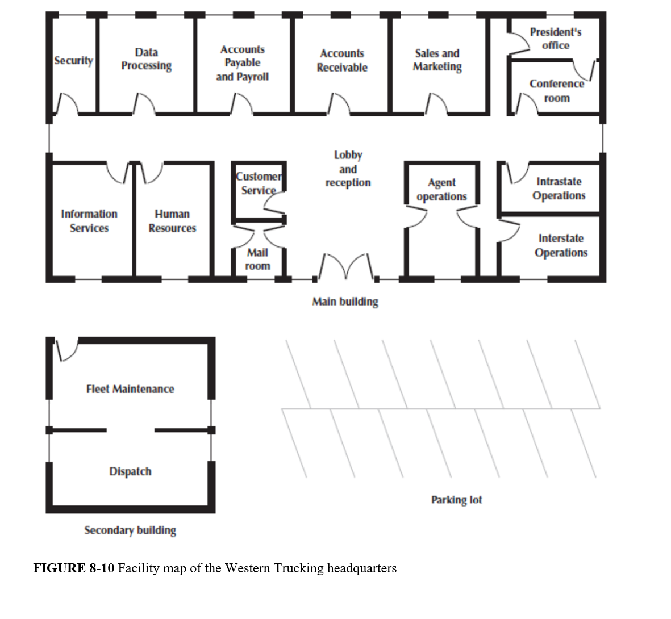

***Assumption***: Every employee will have a VoIP phone.

# **Needs Analysis**

When developing the design for an organization's network, creating a well-thought-out needs analysis in the beginning is an important process for efficient network management and optimization. A needs analysis is specific to an organization's goal and will allow for strategic planning and informed decision-making regarding buying efficient network architecture components. A needs analysis will provide the network components, what application systems will be needed by the whole organization and by specific groups, the users utilizing the network by job functions, and the categorization of the network needs by department.

Specifically for Western Trucking Company, their organization has 16 departments. We first put Security and Data Processing together for North Lan 1 and classified it as high traffic. We found that individuals in the Security department will need to use ADT for surveillance and Access Control List Software and individuals in the Data Processing will be using Amazon Web Services for data storage and ETL processes. In the Security department will sit the network closet, including 7 layer 2 remote switches and a router.

We then set Accounts Payable/Payroll and Accounts Receivable on North Lan 2 and classified it as typical traffic needs. Users in Account Payable/Payroll will need to use Gusto for payroll software and Intuit Quickbooks for accounting software and users in Accounts Receivable will need to also use Intuit Quickbooks for invoicing software.

Next, we set Sales/Marketing, the President's Office, and the Conference Room on North Lan 3, which we classified as typical network needs. Sales and Marketing will use Salesforce for CRM software, MailChimp for digital marketing, and Adobe Photoshop for editing advertisements. The CEO in the President's Office will use Power BI for Dashboard software. The Conference Room will just need to use Microsoft Teams, but this will be used by everyone.

We put Information Services and Human Resources on South Lan 1 and said it will have high traffic needs. The users in Information Services will use Helpdesk for ticketing systems and Slack for IT management software. The users in Human Services will use WorkDay for HR and Recruiting software.

The departments Customer Service and Mail Room were put on South Lan 2, and found to have typical traffic needs. Users in Customer Service will utilize SalesForce for querying orders and users in the Mail Room will use PackageXLogisitics Cloud for mail tracking and management.

The last departments in the first building are Agent Operations, Intrastate Operations and Interstate Operations, and we put these 3 departments on South Lan 3. We classified this as typical traffic needs. Users in Agent Operations will use Salesforce, and users in both Intrastate and Interstate Operations will use Fleet for fleet management software.

The Western Trucking Company also has a second building with the Fleet Maintenance and Dispatch departments, where Fleet Maintenance was put on LAN A classified as typical traffic needs, and Dispatch was put on LAN B and classified as high traffic needs. Users in Fleet Maintenance will use JPRO for vehicle diagnostic software and users in Dispatch will use TruckLogics for GPS tracking and dispatch management software. LAN B will include the network closet for the second building including one router and 3 layer 2 switches.

For the organization as a whole, we decided that every user will need to have the applications Microsoft Outlook for a client email, Microsoft Office 365 for document/team collaboration, Trello for a VOIP communication system, and Jira for a project management software. Every room will have 5 drops placed, 4 for wired and 1 for the access point (the stacked rooms Customer Service/Mail Room, President's Office/Conference Room, and Intrastate Operations/Interstate Operations will share an AP so they will need 4 drops for wired access each room and one shared drop for the AP). Also, one fiber drop will be needed for the campus backbone to connect the main and secondary building routers.

# 

# 

# 

# 

# 

# 

# 

# 

# 

# 

# 

# 

# 

# 

# 

# 

# **Logical Network Design**

A well-created logical network design is the backbone of a business's digital infrastructure. The Logical Network Design serves as the blueprint for organizing and optimizing the needed network resources. Based on assessing the needs analysis, we deemed a few areas to have higher network resource requirements. In our logical network design, the areas divided in green have typical network resource requirements. On the other hand, areas divided in red have higher network resource needs. Additionally, the areas marked in yellow serve as networking closets to store physical hardware. We have also included three purple rows representing our two building backbones and one campus backbone.

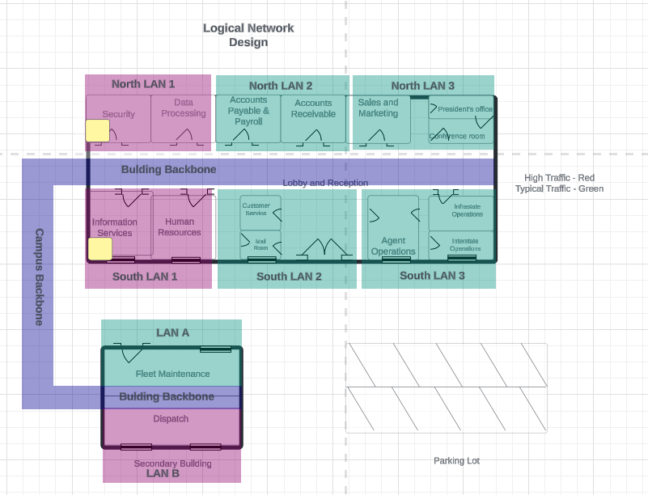

# **Physical Network Design**

A physical network design provides a visual representation of the hardware components needed and the connections within the business’ infrastructure. Using the logical network design CyberSooners created, the physical hardware needed is layed out, including routers, switches, and access points. The network closet is denoted by a yellow square which holds the server rack, including the routers and switches. CyberSooners additionally provided a magnified view of the network closet. CyberSooners also included an access point diagram using 2.4GHz and the specified channels. This physical network design provides a visual roadmap of the connectivity of the network architecture. Twisted pair wiring is represented by solid lines, while fiber connections are represented by dashed lines. Each individual room will require five twisted pair drops, four for wired connections and one for an access point.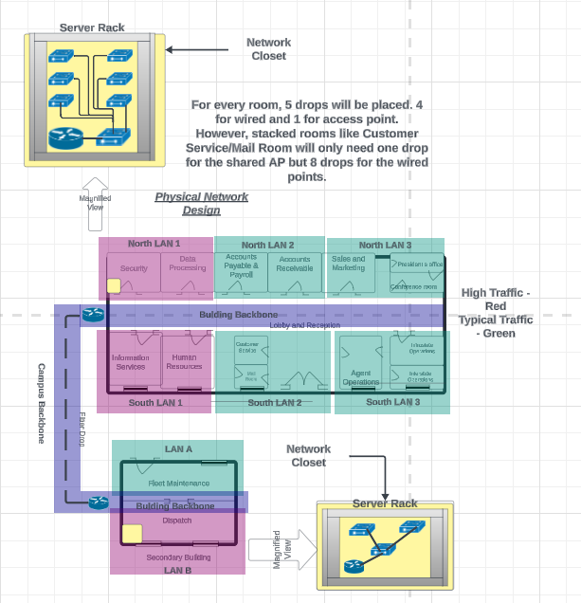

# **Physical Network Design - Access Point Diagram**

This is the access point diagram made by CyberSooners to fully cover the two buildings of Western Trucking. This diagram is based on 2.4GHz and channels 1, 6, and 11. Ten total access points will be used in the main building, and two will be used in the secondary building.

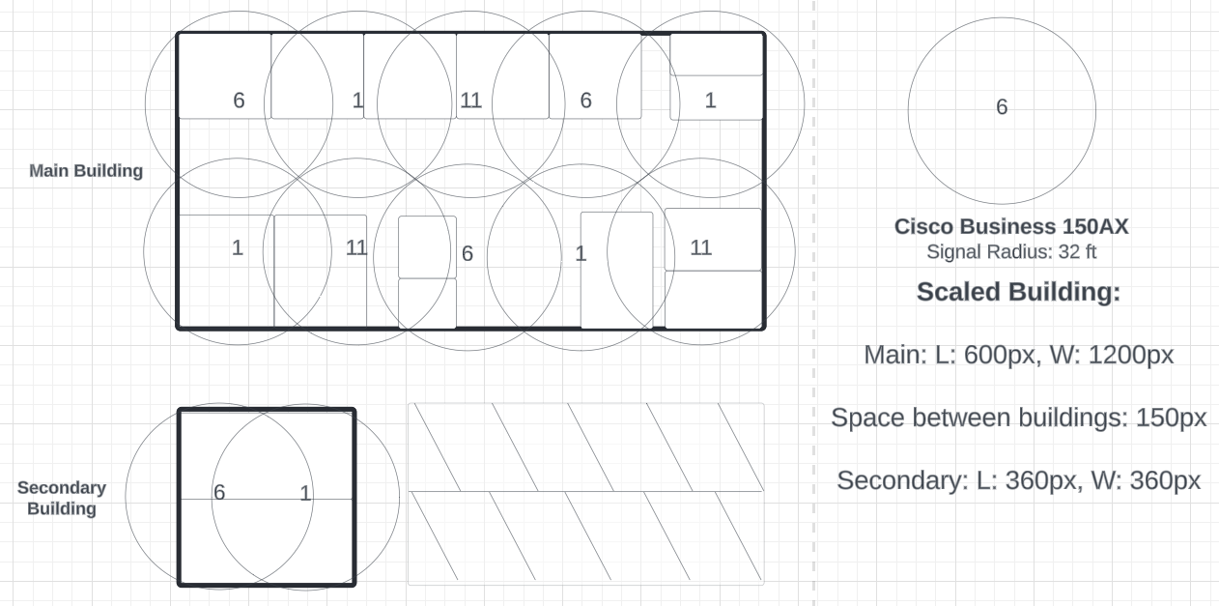

# 

# 

# 

# 

# 

# 

# 

# 

# 

# **Cost Assessment**

For the main building router, we have selected the Cisco Catalyst 8200L-1N-4T as the recommended equipment. It allows high speeds up to 1 gigabit. Additionally, the Catalyst has room for expansion in the future, reducing the need for replacement down the road. It is rack mountable. The Cisco Catalyst 8200L-1N-4T is currently priced at $1,589.99 and has a one year warranty from Cisco. For good to have requirements, CyberSooners recommends the Cisco Catalyst 8300-1N1S-4T2X. This model supports 10 gigabit, while having an additional network module and an additional service module. This will greatly improve the future-proofing of the network. The Catalyst 8300-2N2S is currently priced at $11,924.99 with a one year warranty from Cisco.

For the secondary building, we recommended using the same router placed inside the main building. These routers provide ample upgradability, as well as the support of 1GbE. In addition, these are the more affordable 1GbE routers made by Cisco. For the recommended equipment, we recommend the Cisco Catalyst 8200L-1N-4T. The Cisco Catalyst 8200L-1N-4T is currently priced at $1,589.99 and has a one year warranty from Cisco. For good to have requirements, CyberSooners recommends the Cisco Catalyst 8300-1N1S-4T2X due to the extra expansion slots mentioned previously and 10GbE. The Catalyst 8300-1N1S is currently priced at $11,924.99 with a one year warranty from Cisco.

For the main building and secondary building typical 1GbE switches, we recommended the Cisco Catalyst 1000-8T-E-2G-L as the recommended equipment. It allows for 1GbE speeds, as well as eight total ports for network expansion in the future. This switch is currently priced at $429.99 with a limited lifetime warranty. For the good to have requirements, we recommend the Cisco Meraki Cloud Managed MS120-8. It is also an eight port switch, with 1GbE speeds. The Cisco Meraki is cloud-managed, allowing for port configuration over the web at any given moment, even off campus in certain situations. This Cisco Meraki is currently priced at $1,243.99 with a limited lifetime warranty. Both switches are rack mountable.

For the main building and secondary access points, CyberSooners recommends the Cisco Business 150AX for the recommended equipment. This access point does not provide as fast speeds as the Catalyst, but is substantially cheaper, $149.99 with a three year limited warranty. For the good to have requirements, we recommend the Cisco Catalyst 9162I. This access point provides faster speeds and allows for cloud management, to be controlled on the web. This access point is currently priced at $1,077.99 with a limited lifetime warranty. Both access points are wall or ceiling mountable.

In addition to physical devices, several drops of wire will be necessary for twisted pair and fiber connections. One fiber drop will be needed for router to router connection through the campus background. One drop of fiber connection costs $600. In the network closet, multiple patch cables will be needed to connect the router to the main switch, and switches to other switches. Each room within the buildings will need five total twisted pair drops. Four will be used for physical connections, and one will be used for the access points. For each of the physical connections, one twisted pair drop will be needed each. Each access point also needs a separate twisted pair drop. A twisted pair drop costs $200. In total, one fiber drop will be needed, as well as 79 twisted pair drops to successfully cover each building with four physical connections per room, and access points based on the AP diagram we created. The total cost of fiber and twisted pair drops needed is $16,400.

In conclusion, using the CyberSooners recommended equipment, the total cost of the physical hardware will be $9,279.76. Including the wire drops, the total cost of the network design is $25,079.76. Using the good to have equipment recommendations, the total cost of the physical hardware is $42,025.76. Including the wire drops, the total cost of the network design is $57,825.76.

|  |  |  |  |  |  |
| --- | --- | --- | --- | --- | --- |
| Equipment | Recommended Equipment | Cost & Warranty | Good-to-have Equipment | Cost & Warranty | Quantity |
| Primary Router per building | Cisco Catalyst 8200L-1N-4T | $1,589.99 + one year warranty | Cisco Catalyst 8300-1N1S-4T2X | $11,924.99 + one year warranty | 2 |
| 1GbE switches | Cisco Catalyst 1000-8T-E-2G-L | $429.99 + limited lifetime warranty | Cisco Meraki Cloud Managed MS120-8 | $523.99 + limited lifetime warranty | 10 |
| Access Points | Cisco Business 150AX | $149.99 + 3 year limited warranty | Cisco Catalyst 9162I | $1,077.99 + limited lifetime warranty | 12 |
| Wire Drop | Required: 1 fiber drop | $600 | Required: 76 Twisted-Pair Drops | $15,200 | 77 |

# **Appendix**

## **Team Contract**

|  |
| --- |
|  |

## **Device Specifications**

**Recommended Equipment - Cisco Catalyst 8200L-1N-4T Router**

<https://www.cdw.com/product/cisco-catalyst-8300-2n2s-4t2x-router-rack-mountable/6308366>

* **Processor:** Intel
* **Memory:** 8 GB flash memory installed, 4 GB RAM installed, 32 GB Max Memory Supported
* **Features:** Access Control List (ACL) support, Application Aware Routing (AAR), Application Visibility and Control (AVC), Authentication, Authorization and Accounting (AAA), Bidirectional Forwarding Detection (BFD), Call Admission Control (CAC), Cisco IOS IP Service-Level Agreements (IPSLA), Class of Service (CoS), Class-Based Weighted Fair Queuing (CBWFQ), Datagram Transport Layer Security (DTLS), DHCP client, DHCP server, Embedded Event Manager (EEM), Encapsulated Remote SPAN (ERSPAN), Ethernet Virtual Connections (EVC), Flexible NetFlow (FNF), Forward Error Correction (FEC), Hierarchical Quality of Service (HQoS), High-Level Data Link Control (HDLC), Interactive Voice Response (IVR), Multilink Frame Relay (MLFR), Multilink Point-to-Point Protocol (MLPPP), NAT support, Network-Based Application Recognition (NBAR), PAT support, Point-to-Point Protocol (PPP), Protocol Independent Multicast (PIM), Quality of Service (QoS), Secure Unique Device Identification (SUDI), Service Advertisement Framework (SAF), Source-Specific Multicast (SSM), Syslog support, URL filtering, Weighted Random Early Detection (WRED)
* **Routing Protocol:** BGP, Bidirectional Forwarding Detection (BFD), DVMRP, EIGRP, GRE, HSRP, IGMPv3, IS-IS, MPLS, OSPF, OSPFv3, Policy-based routing (PBR), RIP, RIP-2, VRRP
* **Authentication:** RADIUS, Secure Shell (SSH)
* **Capacity:** Access Control Entries (ACEs) per system (IPv4): 72000, ACLs per system: 4000, Firewall sessions: 512000, IPsec SVTI tunnels: 1500, IPv4 routes: 800000, IPv6 routes: 800000, NAT sessions: 600000, Queues: 16000, SD-WAN overlay tunnels scale: 1500, Virtual Routing and Forwarding (VRF) entries: 2000

**Good-To-Have Equipment - Cisco Catalyst 8300-1N1S-4T2X Router**

<https://www.cdw.com/product/cisco-catalyst-8300-1n1s-4t2x-router-rack-mountable/6296776>

* **Processor:** Intel
* **Memory:** 8 GB flash memory installed, 8 GB RAM installed
* **Features:** Access Control List (ACL) support, Application Aware Routing (AAR), Application Visibility and Control (AVC), Authentication, Authorization and Accounting (AAA), Bidirectional Forwarding Detection (BFD), Call Admission Control (CAC), Cisco IOS IP Service-Level Agreements (IPSLA), Class of Service (CoS), Class-Based Weighted Fair Queuing (CBWFQ), Datagram Transport Layer Security (DTLS), DHCP client, DHCP server, Embedded Event Manager (EEM), Encapsulated Remote SPAN (ERSPAN), Ethernet Virtual Connections (EVC), Flexible NetFlow (FNF), Forward Error Correction (FEC), Hierarchical Quality of Service (HQoS), High-Level Data Link Control (HDLC), Interactive Voice Response (IVR), Multilink Frame Relay (MLFR), Multilink Point-to-Point Protocol (MLPPP), NAT support, Network-Based Application Recognition (NBAR), PAT support, Point-to-Point Protocol (PPP), Protocol Independent Multicast (PIM), Quality of Service (QoS), Service Advertisement Framework (SAF), Source-Specific Multicast (SSM), Syslog support, URL filtering, Weighted Random Early Detection (WRED)
* **Routing Protocol:** BGP, Bidirectional Forwarding Detection (BFD), DVMRP, EIGRP, GRE, HSRP, IGMPv3, IS-IS, MPLS, OSPF, OSPFv3, Policy-based routing (PBR), RIP, RIP-2, VRRP
* **Authentication:** RADIUS, Secure Shell (SSH)
* **Capacity:** Access Control Entries (ACEs) per system (IPv4): 72000, ACL: 4000, Firewall sessions: 512000, IPv4 routes: 1600000, IPv6 routes: 1500000, Maximum overlay tunnels: 6000, NAT sessions: 1200000, Queues: 16000, Virtual Routing and Forwarding (VRF) entries: 4000

**Recommended Equipment - Cisco Catalyst 1000-8T-E-2G-L Network Switch**

<https://www.cdw.com/product/cisco-catalyst-1000-8t-2g-l-switch-8-ports-managed-rack-mountable/6314168>

* **Processor:** 800 megahertz clock speed, ARM
* **Memory:** 256 megabyte flash memory installed, 512 megabyte RAM installed
* **Features:** 802.1x authentication, Access Control List (ACL) support, ARP support, Authentication, Authorization and Accounting (AAA), Auto-uplink (auto MDI/MDI-X), BOOTP support, BPDU Guard, Broadcast Storm Control, Class of Service (CoS), DHCP snooping, DiffServ Code Point (DSCP) support, Dying Gasp support, Dynamic Trunking Protocol (DTP) support, Energy Efficient Ethernet, Fanless, IGMP filtering, Intrusion Detection System (IDS), IP source guard, LACP support, LLDP support, Loopback detection, MAC Access Bypass (MAB), MAC Address Notification, Management Information Base (MIB), Multicast Storm Control, Network Edge Access Topology (NEAT), Port Aggregation Protocol (PAgP) support, Proxy ARP, Quality of Service (QoS), Rapid Per-VLAN Spanning Tree Plus (PVRST+), sFlow, Shaped Round Robin (SRR), SmartPort technology, Spanning-tree Root Guard (STRG), Switched Port Analyzer (SPAN), Unicast Storm Control, Uni-Directional Link Detection (UDLD), User Datagram Protocol (UDP), VLAN Trunking Protocol (VTP), Weighted Tail Drop (WTD)
* **Ports:** 8
* **Routing Protocol**: IGMP, MLD, MLDv2, MSTP, RSTP, STP
* **Switching Type:** Gigabit Ethernet
* Authentication: Kerberos, RADIUS, Secure Shell (SSH), Secure Shell v.2 (SSH2), TACACS+
* **Capacity:** Active VLANs: 256, IPv4 routes (Multicast): 1024, IPv4 routes (static): 16, IPv4 unicast direct routes: 542, IPv4 unicast indirect routes: 256, IPv4/MAC security ACEs: 600, IPv6 groups (Multicast): 1024, IPv6 routes (static): 16, IPv6 security ACEs: 600, IPv6 unicast direct routes: 414, IPv6 unicast indirect routes: 128, MTU-L3 packet: 9198 byte, SPAN sessions: 4, STP instances: 64, Unicast MAC addresses: 15360, VLAN IDs: 4094
* **Performance:** Forwarding bandwidth: 10 Gbps, Forwarding rate (64-byte L3 packets): 14.88 Mpps, Switching bandwidth: 20 Gbps

**Good-To-Have Equipment - Cisco Meraki Cloud Managed MS120-8 Network Switch**

<https://www.cdw.com/product/cisco-meraki-cloud-managed-ms120-8-switch-8-ports-managed/4847265>

* **Features:** Access Control List (ACL) support, Auto-negotiation, Auto-uplink (auto MDI/MDI-X), Broadcast Storm Control, Cisco Discovery Protocol, Crossover detection, DHCP client, DHCP snooping, DSCP to CoS Mutation, E-mail alert, Fanless, Firmware upgradable, Flow control, IGMP snooping, Port mirroring, Quality of Service (QoS), Rapid Spanning Tree Protocol (RSTP) support, Role-Based Access Control (RBAC), Security lock slot (cable lock sold separately), Single Sign-On (SSO) support, SMS alert, Spanning Tree Protocol (STP) support, STP BPDU Guard, STP Root Guard, Syslog support, VLAN support, Zero-touch provisioning (ZTP)
* **Ports:** 8
* **Switching Type:** Gigabit Ethernet
* **Authentication:** RADIUS
* **Capacity:** MAC forwarding entries: 16000, VLANs supported: 4094
* **Performance:** Forwarding rate: 14.88 Mpps, Switching capacity: 20 Gbps

**Recommended Equipment - Cisco Business 150AX AP**

<https://www.cdw.ca/product/cisco-business-150ax-wireless-access-point-bluetooth-802.11a-b-gcc/7443454>

* **Processor:** 1GHz
* **Memory:** Flash Memory Installed: 512MB, RAM installed: 1GB
* **Features:** 2x2 MU-MIMO technology, 802.1x authentication, Authentication, Authorization and Accounting (AAA), Beamforming technology, BSS Coloring, Cyclic shift diversity (CSD), DFS support, Dynamic Frequency Selection (DFS), Manageable, Maximum Ratio Combining (MRC), Mesh networking, Target Wait Time (TWT), VLAN support, Wall mountable, Wi-Fi Multimedia (WMM) support
* **Ports:** 1
* **Data Link Protocol:** 802.11ax, IEEE 802.11a, IEEE 802.11ac Wave 2, IEEE 802.11b, IEEE 802.11g, IEEE 802.11n
* **Authentication:**EAP-FAST, EAP-SIM, EAP-TLS, Extensible Authentication Protocol (EAP), RADIUS
* **Capacity:**VLANs supported: 16, Wireless clients per Wi-Fi radio: 200, Wireless clients: 400

**Good-To-Have Equipment - Cisco Catalyst 9162I AP**

<https://www.cdw.com/product/cisco-catalyst-9162i-wireless-access-point-bluetooth-wi-fi-6e-cloud/7178007>

* **Memory:** Flash Memory Installed: 1GB, RAM Installed 2GB
* **Features:** 2x2:2 MU-MIMO technology, Band steering, Beamforming technology, BSS Coloring, Cisco Trust Anchor module, CleanAir Pro technology, Cyclic shift diversity (CSD), Dynamic Frequency Selection (DFS), High Efficiency (HE) support, Image signing, Intelligent capture, LLDP support, Maximum Ratio Combining (MRC), Packet aggregation A-MPDU, Packet aggregation A-MSDU, PowerSave, Realtime network analytics, Secure boot, Security slot (Kensington security lock compatible), Target Wake Time (TWT), Tri-Band 2x2, Universal power over Ethernet (UPOE), WLAN controller mode
* **Ports:** 2
* **Data Link Protocol: ​​**2.5 Gigabit Ethernet, Bluetooth 5.1 LE, Ethernet, Fast Ethernet, Gigabit Ethernet, IEEE 802.11a, IEEE 802.11ac, IEEE 802.11ax (Wi-Fi 6E), IEEE 802.11b, IEEE 802.11g, IEEE 802.11n
* **Authentication:** EAP-FAST, EAP-SIM, Extensible Authentication Protocol (EAP), MS-CHAP, MS-CHAP v.2